**Erase TOOL**

Under Commands -> Analysis Tools -> Erase

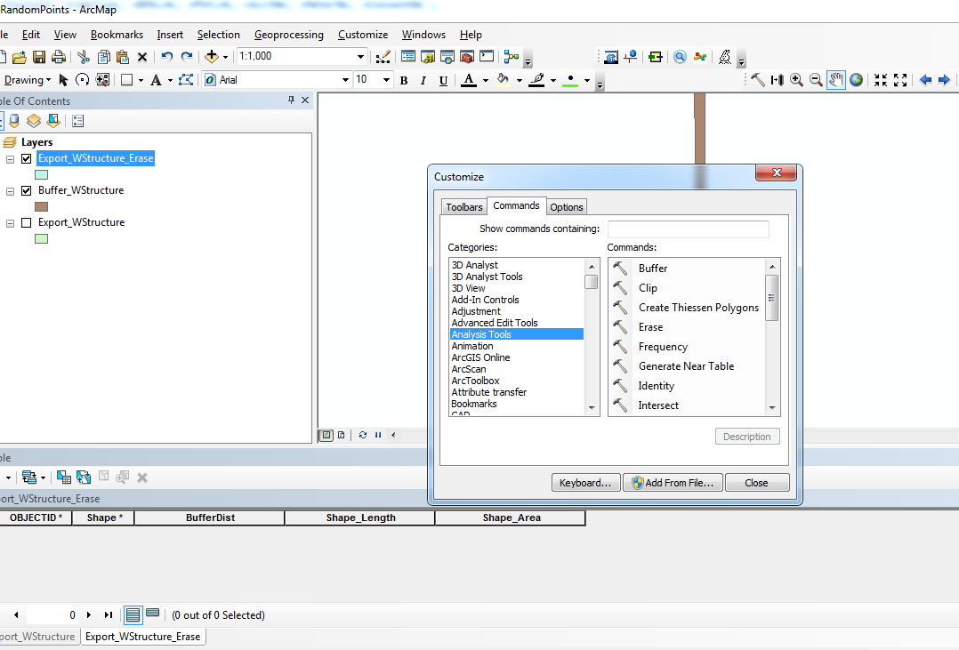

Input Feature -> Feature to be removed

Erase Feature -> Bound area

